ANNEX I

SUMMARY OF PRODUCT CHARACTERISTICS

1. NAME OF THE MEDICINAL PRODUCT

EGRIFTA 2 mg powder for solution for injection

2. QUALITATIVE AND QUANTITATIVE COMPOSITION

Each vial contains 2 mg of tesamorelin (as acetate). After reconstitution, each ml of the solution contains 1 mg of tesamorelin (as acetate).

3. PHARMACEUTICAL form

Powder for solution for injection (powder for injection).

White to off-white, lyophilised powder.

4. Clinical particulars

  - Therapeutic indications

EGRIFTA is indicated for the treatment of excess visceral abdominal fat in treatment experienced HIV-infected adult patients. Patients should be identified by waist circumference of at least 95cm in men, and of 94 cm in women.

EGRIFTA is not indicated for weight loss management (weight neutral effect).

  - Posology and method of administration

Posology

The recommended dose is 2 mg injected subcutaneously once daily, preferably in the morning.

If a dose is missed then the next dose should be taken at the scheduled time. The missed dose should not be taken.

Special populations

Elderly population

There is no information on the use of EGRIFTA in patients aged over 65 years with HIV infection and lipodystrophy.. Therefore EGRIFTA should be administered with caution in patients above 65.

Renal and hepatic impairment

As safety, efficacy and pharmacokinetics in patients with renal or hepatic impairment have not been established, patients with ALT or AST greater than threetimes the Upper Limit of Normal, and/or serum creatinine greater than 133 µmol/L (1.5 mg/dL) should not be treated with EGRIFTA.

Paediatric population

The safety and efficacy of EGRIFTA in children (0-18 years) has not been established. No data are available. EGRIFTA should not be administered to children.

Method of administration

For instructions on reconstitution of the medicinal product before administration, see section.6 of leaflet.Additional information is provided in the Detailed Instructions for Use at the end of the Package Leaflet.

After reconstitution with 2.1 ml of water for injections, the solution is clear and colourless. Reconstituted EGRIFTA solution should always be inspected visually for particulate matter and discoloration prior to administration. EGRIFTA should be injected only if the solution is clear, colourless and without particulate matter.

If not used immediately, the reconstituted EGRIFTA solution should be discarded. The reconstituted solution should not be frozen or refrigerated.

The dose should be injected subcutaneously. The recommended administration site is the abdomen. Injection sites should be rotated to different areas of the abdomen (see section 4.4). EGRIFTA should not be injected into scar tissue, bruises or the navel.

4.3 Contraindications

- Hypersensitivity to the active substance(s) or to any of the excipients listed in section 6.1.
- Disruption of the hypothalamic-pituitary axis due to hypophysectomy, hypopituitarism, history of pituitary tumour/ surgery, head irradiation or head trauma.
- Active malignancy (newly diagnosed or recurrent).
- Pregnancy.
- Breastfeeding.
- Paediatric population.

4.4 Special warnings and precautions for use

Hypersensitivity reactions
Hypersensitivity reactions may occur in patients treated with EGRIFTA. These reactions included pruritus, erythema, flushing, urticaria, and other rash. In cases of suspected hypersensitivity reactions, patients should be advised to discontinue treatment with EGRIFTA immediately and seek prompt medical attention.
Neoplasms
EGRIFTA induces the release of endogenous GH, a known growth factor. Thus, patients with active malignancy should not be treated with EGRIFTA (see section 4.3). Any pre-existing malignancy should be inactive and its treatment complete prior to initiating therapy with EGRIFTA.

For patients with a history of treated and stable malignancies, therapy should be initiated only after careful evaluation of the potential benefit of treatment relative to the risk of re-activation of the underlying malignancy.

For patients with a history of non-malignant neoplasms, EGRIFTA therapy should be initiated after careful evaluation of the potential benefit of treatment.

In addition, the decision to initiate therapy should be considered carefully based on the increased background risk of malignancies in HIV-positive patients.
IGF-1
EGRIFTA stimulates GH production and increases serum IGF-1. Given that IGF-1 is a growth factor and the effect of prolonged elevations in IGF-1 levels on the development or progression of malignancies is unknown, IGF-1 levels should be monitored during EGRIFTA therapy.
Glucose
EGRIFTA treatment may result in glucose intolerance. Caution should be exercised in treating HIV-positive patients with lipodystrophy with EGRIFTA if they develop glucose intolerance or diabetes.
Fluid retention
Fluid retention may occur during therapy and is thought to be related to the induction of GH secretion. It manifests as increased tissue turgor and musculoskeletal discomfort resulting in a variety of adverse events (e.g. oedema, arthralgia, carpal tunnel syndrome) which are either transient or resolve with discontinuation of treatment.
Injection site reactions
EGRIFTA treatment may be associated with injection site reactions, including injection site erythema, pruritus, pain, irritation, and bruising. In order to reduce the incidence of injection site reactions, it is recommended to rotate the site of injection to different areas of the abdomen.
Acute critical illness
Increased mortality in patients with acute critical illness due to complications following open heart surgery, abdominal surgery or multiple accidental trauma, or those with acute respiratory failure has been reported after treatment with pharmacologic amounts of growth hormone. EGRIFTA has not been studied in patients with acute critical illness. Since EGRIFTA stimulates growth hormone production, careful consideration should be given to discontinuing EGRIFTA in critically ill patients.

4.5 Interaction with other medicinal products and other forms of interaction

Published data indicate that GH may modulate cytochrome P450 (CYP450) activity. Data from drug-drug interaction studies using simvastatin (a CYP3A-substrate) or ritonavir (a CYP3A-inhibitor) showed that EGRIFTA had no significant impact on the pharmacokinetic profiles of either drug when co-administered in healthy subjects. These results suggest that EGRIFTA does not significantly affect CYP3A activity. Therefore, either medicinal product may be co-administered with EGRIFTA without changing their dosing regimen.
Tesamorelin should not be co-administered with GH or GRF products, GH secretagogues, IGF-1, or IGFBP-3 products.

Because of documented GH effect on cortisone, and due to tesamorelin mechanism of action, dose adaptation should be considered for patients receiving a glucocorticoid to treat hypoadrenalism.

No other drug-drug interactions were conducted. However, during clinical trials, administration of tesamorelin for up to 52 weeks did not adversely alter antiretroviral effectiveness, as shown by unaffected mean circulating levels of CD4 counts or HIV-1 RNA (viral load).

4.6 Fertility, pregnancy and lactation

Women of childbearing potential/Contraception in males and females

Any contraceptive precautions aimed at preventing HIV transmission must continue to be strictly observed during treatment with EGRIFTA.

Pregnancy

There are no data from the use of tesamorelin in pregnant women and its use is therefore contraindicated in pregnancy (see section 4.3).
If pregnancy occurs, EGRIFTA therapy should be discontinued immediately.

Breastfeeding

It is not known whether tesamorelin is excreted in human milk.

HIV-infected mothers should not breastfeed their infants due to the risk of HIV transmission.

Fertility

For tesamorelin no clinical data on exposed pregnancies are available.

4.7 Effects on ability to drive and use machines

EGRIFTA has no or negligible influence on the ability to drive or use machines.

  - Undesirable effects

EGRIFTA treatment should be stopped and the patient should consult a physician immediately if he/she experiences the following symptoms following an injection:

- feeling faint or fainting
- rashes or itching of the skin extending larger than the injection area or to other parts of the body
- skin welts or hives that develop around the injection area or on other parts of the body
- swelling of the face or throat
- shortness of breath or trouble breathing
- slurred speech
- chest pain
- palpitations

Adverse reactions are defined as all treatment-emergent adverse events occurring at a greater incidence in the active treatment group compared to the placebo group and considered to be related to EGRIFTA or having a potential pharmacological relationship.

Summary of the safety profile

The most significant adverse reactions are hypersensitivity reactions which occurred in about 3% of the EGRIFTA-treated subjects (see section 4.4). The most commonly reported adverse reactions are injection site reactions (e.g. injection site erythema and injection site pruritus) and reactions known to be related to growth hormone (e.g. arthralgia, pain in extremity, oedema peripheral and myalgia).

Tabulated list of adverse reactions
Adverse reactions are tabulated below according to System Organ Class. Frequencies are assigned as follows: very common (≥1/10), common (≥1/100 to <1/10), and uncommon (≥1/1,000 to ≤1/100). Of note, there were no cases of rare or very rare undesirable effects.
Adverse reactions that occurred in EGRIFTA -treated patients at an incidence greater or equal to placebo, are presented for the combined main studies (Table 1).

Table 1: Adverses reactions during the 26-Week Main Phase of the Combined Studies
System Organ Class | Very common | Common | Uncommon
Cardiac disorders |  |  | Palpitations  TachycardiaCardiac failure congestive
Ear and labyrinth disorders |  |  | Vertigo
Eye disorders |  |  | Eye swelling  Abnormal sensation in eye  Lacrimation increased  Mydriasis  Visual disturbance
Gastrointestinal disorders |  | Nausea | Abdominal pain upper  Dry mouth  Flatulence  Vomiting  Abdominal pain  Paraesthesia oral  Abdominal discomfort  Gastrooesophageal reflux disease  Gingival swelling  Lip swelling  Swollen tongue
General disorders and administration site conditions |  | Injection site erythema  Injection site pruritus  Oedema peripheral  Injection site pain  Injection site irritation  Injection site urticaria  Injection site haemorrhage  Injection site reaction  Injection site swelling | Pyrexia  Injection site mass  Injection site rash  Pain  Chest pain  Asthenia  Energy increased  Injection site nodule  Chest discomfort  Cyst  Fat tissue increased  Feeling cold  Injection site anaesthesia  Injection site dryness  Injection site fibrosis  Injection site haematoma  Injection site induration  Injection site oedema  Local reaction  Local swelling  Loss of control of legs  Malaise  Oedema  Puncture site reaction
Immune system disorders |  |  | Hypersensitivity
Infections and infestations |  |  | Bronchitis  Folliculitis  Gingival infection  Herpes virus infection  Herpes zoster  Injection site infection  Proctitis herpes  Rhinitis  Sepsis
Injury, poisoning and procedural complications |  |  | Contusion  Epicondylitis  Sunburn
Investigations |  |  | Blood creatine phosphokinase increased  Weight increased  Blood glucose increased  Blood amylase increased  Blood insulin increased  Blood urine present  Hepatic enzyme increased  Lipase increased  Protein urine present  Urine colour abnormal  Urine output decreased  Weight decreased
Metabolism and nutrition disorders |  |  | Increased appetite  Decreased appetite  Hypertriglyceridaemia  Glucose tolerance impaired  Hyperglycaemia  Hypercholesterolaemia  Hyperlipidaemia  Impaired fasting glucose
Musculoskeletal and connective tissue disorders | Arthralgia | Myalgia  Pain in extremity  Joint stiffness  Musculoskeletal stiffness | Musculoskeletal pain  Joint swelling  Neck pain  Muscular weakness  Tenosynovitis stenosans  Trigger finger  Arthritis  Arthropathy  Joint ankylosis  Joint range of motion decreased  Mobility decreased  Musculoskeletal chest pain  Plantar fasciitis
Nervous system disorders |  | Headache  Paraesthesia  Hypoaesthesia  Carpal tunnel syndrome | Neuropathy peripheral  Dysgeusia  Migraine  Tension headache  Ageusia  Neuralgia  Tinel's sign  Tremor
Psychiatric disorders |  |  | Depression  Agitation  Frustration  Libido increased  Mood swings  Stress
Renal and urinary disorders |  |  | Dysuria  Urine odour abnormal
Reproductive system and breast disorders |  |  | Benign prostatic hyperplasia  Breast cyst  Breast enlargement  Breast swelling  Breast tenderness  Fibrocystic breast disease  Genital haemorrhage  Gynaecomastia  Nipple pain  Spontaneous penile erection
Respiratory, thoracic and mediastinal disorders |  |  | Dyspnoea  Cough  Pharyngeal oedema  Productive cough  Rhinitis allergic  Snoring
Skin and subcutaneous tissue disorders |  | Rash  Pruritus | Urticaria  Erythema  Acne  Dry skin  Night sweats  Swelling face  Alopecia  Pruritus generalised  Rash papular  Rosacea  Skin disorder  Skin exfoliation  Subcutaneous nodule
Vascular disorders |  |  | Hypertension

Description of selected adverse reactions

In the double-blind Extension Phase, patients on EGRIFTA completing the 26-week Main Phase were re-randomized to receive 2 mg EGRIFTA or placebo. Adverse reactions for those patients continuing on EGRIFTA for an additional 26 weeks, in general, remained the same or decreased in frequency, compared to the main phase study. Those that decreased in frequency category were: injection site irritation, injection site reaction, injection site swelling, joint stiffness, musculoskeletal stiffness, carpal tunnel syndrome and arthralgia. The only exception was neuropathy peripheral which changed from uncommon (0.7%) to common (1.3%) during the extension.
There were new adverse reactions that became present in the extension phase compared to the main phase, all of which were classified in the uncommon category and were: tinnitus, Cushing's syndrome, chorioretinopathy, abdominal distension, gastritis, stomach discomfort, axillary pain, lower respiratory tract infection, nasopharyngitis, urinary tract infection, heart rate increased, sensation of heaviness, dizziness, lethargy, memory impairment, sciatica, sleep disorder, hyperhidrosis and hot flush.
Two hundred and six of 543 (50.5%) patients exposed to EGRIFTA in Phase 3 studies developed IgG antibodies by week 26 of treatment. A relatively high prevalence was maintained during continuous treatment for 52 weeks and subsequently decreased on treatment discontinuation.
Despite this percentage of IgG antibody development, adverse reactions suggestive of hypersensitivity were relatively uncommon suggesting that antibody development is not predictive of clinical manifestation of hypersensitivity.
In the patients with IgG antibodies treated with EGRIFTA for 52 weeks, 5% and 10% were found to be hGRF neutralizing antibody (Nab)-positive and EGRIFTAneutralizing antibody (Nab)-positive, respectively. However, the presence or absence of hGRF NAbs or EGRIFTA NAbs had no apparent effect on AE profiles or IGF-1 or VAT results. These observations suggest that the presence of these antibodies has no clinically significant effects on GH release.

There is insufficient experience of the use of tesamorelin in special populations such as the HIV elderly and patients with renal and/or hepatic impairment to draw conclusions about the safety of tesamorelin in these populations. Therefore EGRIFTA should be administered with caution in patients above 65. As for patients with renal or hepatic impairment, they should not be treated with EGRIFTA if they present with ALT or AST greater than three times the Upper Limit of Normal, and/or serum creatinine greater than 133 µmol/l (1.5 mg/dl).

4.9 Overdose

No data are available on overdose. However, the potential for overdose is minimal since the patient will need to reconstitute one vial of tesamorelin per injection per day of the proposed formulation. Also, since the volume for subcutaneous injection is large, 2 ml, it is unlikely that patients will inject more than the recommended dose.

5. PHARMACOLOGICAL PROPERTIES

5.1 Pharmacodynamic properties

Pharmacotherapeutic group: Pituitary and hypothalamic hormones and analogues, Somatropin and somatropin agonists; ATC code H01AC06.

Mechanism of action

In vitro, tesamorelin binds and stimulates human GRF receptors with similar potency as the natural GRF. Growth Hormone-Releasing Factor (GRF), also known as Growth Hormone-Releasing Hormone, is a hypothalamic peptide that acts on the pituitary somatotroph cells to stimulate the synthesis and pulsatile release of endogenous growth hormone. Growth hormone has been shown to be both anabolic and lipolytic. It exerts its effects by interacting with specific receptors on a variety of target cells, including chondrocytes, osteoblasts, myocytes, hepatocytes, and adipocytes, resulting in a host of pharmacodynamic effects. Some, but not all these effects, are primarily mediated by IGF-1 produced in the liver and in peripheral tissues.

The results of both experimental animal and human studies have shown that GH can reduce total fat mass through a combination of several actions, including inhibition of adipocyte differentiation and stimulation of fat mobilization and oxidation. Also, GH is an anabolic agent that promotes urinary nitrogen retention, uptake of amino acids by muscle cells, and protein synthesis in various tissues.

Pharmacodynamic effects

Effects on GH and IGF-1 levels

A Phase I randomized, 2-way cross-over study showed that treatment with 2 mg tesamorelin increased mean GH secretion in a pulsatile fashion.

Tesamorelin was associated with significant increases in IGF-1 (baseline = 153.7 ± 62.89 ng/ml; Week 26 = 261.59 ± 123.64 ng/ml) and insulin-like growth factor binding protein-3 (IGFBP-3) levels (baseline = 2.81 ± 0.89 mg/l; Week 26 = 3.43 ± 0.99 mg/l) in clinical studies.

Effects on other pituitary hormones

No clinically significant changes in the levels of other pituitary hormones, including thyroid-stimulating hormone (TSH), luteinizing hormone (LH), adrenocorticotropic hormone (ACTH) and prolactin, were observed in subjects receiving EGRIFTA in Phase 3 clinical trials.

Clinical efficacy and safety

Two multicenter, randomized, double-blind, placebo-controlled studies were conducted in HIV-infected patients with lipodystrophy and excess abdominal fat. (abdominal lipohypertrophy). Main inclusion criteria were: age 18-65 years, fasting blood glucose ≤150 mg/dl (8.33 mmol/l), waist circumference (WC) ≥95 cm (men) or ≥94 cm (women) and waist-to-hip ratio (WHR) ≥0.94 (men) or ≥0.88 (women). Main exclusion criteria included body mass index (BMI) ≤20 kg/m², type 1 diabetes, type 2 diabetes if previously treated with insulin or with oral hypoglycemic or insulin sensitizing agents, history of malignancy, and hypopituitarism. Patients were on a stable anti-retroviral regimen. Patients were randomized in a 2:1 ratio to receive 2 mg EGRIFTA or placebo daily for 26 weeks (Main Phase). The primary efficacy variable was the percent change from baseline to Week 26 in VAT, as assessed by computed tomography (CT) scan at L4-L5 vertebral level. Secondary endpoints included changes from baseline in patient-reported outcomes related to body image, triglycerides, ratio of total cholesterol to high-density lipoprotein (HDL) cholesterol, IGF-1 levels, and safety parameters. Other endpoints included changes from baseline in WC, WHR, abdominal subcutaneous tissue (SAT), trunk fat, lean body mass, and limb fat.

EGRIFTA-treated patients completing the 26-week treatment period were re-randomized to blinded therapy with either daily placebo or 2 mg EGRIFTA for an additional 26-week treatment period (Extension Phase) in order to assess maintenance of VAT reduction and to gather long-term safety data.

Main Phase (Baseline to Week 26):

STUDY 1

This study randomized 412 HIV-infected patients with lipodystrophy and excess abdominal fat to receive either EGRIFTA (N=273) or placebo (N=137). At baseline for the two groups combined, mean age was 48 years; 86% were male; 75% were white, 14% were Black/African American, and 8% were Hispanic; mean weight was 90 kg; mean BMI was 29 kg/m²; mean WC was 104 cm; mean hip circumference was 100 cm; mean WHR was 1.05; mean VAT was 176 cm²; mean CD4 cell count was 606 cells/mm³; 69% had undetectable viral load (<50 copies/ml). 33.7% of those randomized to EGRIFTA and 36.6% of those randomized to placebo had impaired glucose tolerance, while 5.6% of patients randomized to EGRIFTA and 6.7% of those randomized to placebo had diet-controlled diabetes mellitus. The twenty-six week completion rate in Study 1 was 80%.

STUDY 2

This study randomized 404 HIV-infected patients with lipodystrophy and excess abdominal fat to receive either EGRIFTA (N=270) or placebo (N=126). At baseline for the two groups combined, mean age was 48 years; 84% were male; 77% were white, 12% were Black/African American, and 9% were Hispanic; mean weight was 88 kg; mean BMI was 29 kg/m²; mean WC was 105 cm; mean hip circumference was 100 cm; mean WHR was 1.05; mean VAT was 189 cm²; mean CD4 cell count was 592 cells/mm³; 83% had undetectable viral load (<50 copies/ml). At study entry, 44.1% of patients randomized to EGRIFTA and 39.7% of those randomized to placebo had impaired glucose tolerance, while 9.3% of patients randomized to EGRIFTA and 9.5% of those randomized to placebo had diet-controlled diabetes mellitus. The twenty-six week completion rate in Study 2 was 74%.

Changes from Baseline to Week 26 in VAT (cm²) by Treatment Group (Intent-To-Treat Population with Last Observation Carried Forward)
MAIN PHASE (Baseline-Week 26)
 | Study 1 |  | Study 2
 | EGRIFTA  (N=273) | Placebo  (N=137) | EGRIFTA  (N=270) | Placebo  (N=126)
Baseline (cm²) | 178 (77) | 171 (77) | 186 (87) | 195 (95)
Change (cm²) | -27 | 4 | -21 | -0
Mean treatment difference (95% CI) | -31 (-39,-24) |  | -21 (-29,-12)
Mean Change (%)¹ | -18 | 2 | -14 | -2
Mean Treatment difference (95% CI)¹ | -20 (-24, -15) |  | -12 (-16, -7)
Baseline data are expressed as mean (standard deviation (SD)); Change refers to least-squares means (LSM); CI: confidence interval.
¹Results derived from the statistical model: Ln(VAT Week 26/VAT Baseline) = Ln(VAT Baseline) + treatment group

In the intent-to-treat (ITT) population using last observation carried forward (LOCF) analysis, 57.6% of patients in the tesamorelin group vs. 29.4% of patients in the placebo group were responders, i.e., lost at least 8% of their baseline VAT, at Week 26 of treatment (p<0.001 for tesamorelin vs. placebo). In the per-protocol (PP) population-Observed Case (OC) analysis, the proportion of VAT responders at Week 26 was 68.8% and 32.6% in the tesamorelin and placebo groups, respectively (p<0.001).

Changes from Baseline to Week 26 in Metabolic and Body Composition Parameters by Treatment Group (Intent-To-Treat Population with Last Observation Carried Forward)
MAIN PHASE (Baseline-Week 26)
 |  | STUDY 1 |  |  | STUDY 2
 |  | EGRIFTA  (N=273) |  | Placebo  (N=137) | EGRIFTA  (N=270) | Placebo  (N=126)
IGF-1  (ng/ml) | Baseline | 161 (59) |  | 168 (75) | 146 (66) | 149 (59)
IGF-1  (ng/ml) | Change | 107 |  | -15 | 108 | 3
IGF-1  (ng/ml) | 95% CI | 101, 141 |  |  | 85, 126
IGFBP-3 (mg/l) | Baseline |  | 3 (1) | 3 (1) | 3 (1) | 3 (1)
IGFBP-3 (mg/l) | Change |  | 0.4 | -0.2 | 0.8 | 0
IGFBP-3 (mg/l) | 95% CI |  | 0.5, 0.8 |  | 0.5, 1.0
Trunk Fat  (kg) | Baseline | 15 (6) |  | 15 (6) | 15 (5) | 15 (5)
Trunk Fat  (kg) | Change | -1 |  | 0.4 | -1 | 0.2
Trunk Fat  (kg) | 95% CI | -1.8, -1.0 |  |  | -1.4, -0.6
Lean Body Mass  (kg) | Baseline | 62 (10) |  | 61 (10) | 62 (10) | 61 (11)
Lean Body Mass  (kg) | Change | 1 |  | -0.2 | 1 | 0
Lean Body Mass  (kg) | 95% CI | 1.1, 2.0 |  |  | 0.8, 1.8
SAT (cm²) | Baseline | 231 (127) |  | 239 (133) | 231 (120) | 226 (112)
SAT (cm²) | Change | -3 |  | 2 | -1 | 1.0
SAT (cm²) | 95% CI | -12, 0.1 |  |  | -9.0, 4.6
Waist Circumference (cm) | Baseline | 104 (10) |  | 105 (9) | 105 (9) | 105 (9)
Waist Circumference (cm) | Change | -3 (5) |  | -1 (4) | -2 (5) | -1 (5)
Waist Circumference (cm) | 95% CI | -2.8, -0.9 |  |  | -2.5, -0.3
Triglycerides (mg/dl) ª | Baseline | 252 (188) |  | 234 (145) | 239 (261) | 223 (144)
Triglycerides (mg/dl) ª | Change | -48 |  | 5 | -19 | 1
Triglycerides (mg/dl) ª | 95% CI | -75, -30 |  |  | -44, 4
Total cholesterol:  HDL-C ratio ª | Baseline | 5 (1) |  | 4 (1) | 5 (2) | 5 (2)
Total cholesterol:  HDL-C ratio ª | Change | 0 |  | 0 | 0 | 0
Total cholesterol:  HDL-C ratio ª | 95% CI | -0.7, -0.3 |  |  | -0.4, 0
Baseline data are expressed as mean (SD); Change refers to least-square means (LSM) for change from baseline to Week 26; 95% CI: 95% confidence interval for LSM differences.
ª The clinical relevance of these changes in lipids is unknown. Long-term cardiovascular benefit and safety of EGRIFTA have not been studied.

For labeling purposes, the following hierarchical testing procedure for the secondary endpoints was pre-specified in the LIPO-010 and CTR-1011 study protocols and statistical analysis plans:

Study 1 testing order:
  - Change from baseline to Week 26 in VAT
  - Belly Appearance Distress change score (using the supportive analysis: non-parametric ANCOVA)
  - Change from baseline to Week 26 in TC:HDL-C ratio
  - Change from baseline to Week 26 in triglycerides

Study 2 testing order:
  - Change from baseline to Week 26 in VAT
  - Belly Appearance Distress change score (using the main analysis: non-parametric ANCOVA) & change from baseline to Week 26 in triglycerides using Hochberg’s adjustment
  - Change from baseline to Week 26 in TC:HDL-C ratio

The table below summarizes the results of these analyses:

Overview of Ranked Secondary Variables for Study TH9507/III/LIPO/010
and Study TH9507-CTR-1011
Secondary Endpoint | Ranking of Endpoint
Secondary Endpoint | Study TH9507/III/LIPO/010 | Study TH9507-CTR-1011
Belly appearance distress change score (change from baseline) | 0.028 | 0.022*
Change from baseline to Week 26 in triglycerides | <0.001 | not significant
Change from baseline to Week 26 in total cholesterol:HDL-C ratio | <0.001 | not significant
* Statistically significant using gatekeeper based on ranked primary ANCOVA (p<0.025 as per Hochberg).

Based on the gatekeeper strategy and on the most appropriate statistical analysis for Belly Appearance Distress (non-parametric ANCOVA) for both studies, Belly appearance distress was considered as statistically significant in both studies. Triglycerides and Total Cholesterol:HDL-C ratio were significant in Study 1, but not in Study 2.

Extension Phase (Weeks 26-52):

STUDY 1
This study re-randomized 207 HIV-infected patients with lipodystrophy who completed EGRIFTA treatment in the Main Phase to receive either EGRIFTA (N=154) or placebo (N=50) for an additional 26-week duration (3:1 randomization ratio). At baseline (Week 26) for the two groups combined, mean age was 48 years; 88% were male; 78% were white, 12% were Black/African American, and 8% were Hispanic; mean weight was 90 kg; mean BMI was 29 kg/m²; mean WC was 102 cm; mean hip circumference was 100 cm; mean WHR was 1.01; mean VAT was 145 cm²; mean CD4 cell count was 639 cells/mm³; 68% had undetectable viral load (<50 copies/ml). 36.6% of EGRIFTA-treated patients completing the 26-week treatment period who were re-randomized to EGRIFTA (T-T group) had impaired glucose tolerance compared to 32.0% of those re-randomized to placebo. 2.0% of patients re-randomized to EGRIFTA and 6.0% of those re-randomized to placebo had diet-controlled diabetes mellitus. The completion rate for patients in the extension phase of Study 1 was 83%.

STUDY 2
This study re-randomized 177 HIV-infected patients with lipodystrophy who completed EGRIFTA treatment in the Main Phase to receive either EGRIFTA (N=92) or placebo (N=85) for an additional 26-week duration (1:1 randomization ratio). At baseline (Week 26) for the two groups combined, mean age was 48 years; 90% were male; 84% were white, 9% were Black/African American, and 7% were Hispanic; mean weight was 89 kg; mean BMI was 28 kg/m²; mean WC was 105 cm; mean hip circumference was 100 cm; mean WHR was 1.02; mean VAT was 172 cm²; mean CD4 cell count was 579 cells/mm³; 82% had undetectable viral load (<50 copies/ml). 48.9% of EGRIFTA-treated patients completing the 26-week treatment period who were re-randomized to EGRIFTA (T-T group) had impaired glucose tolerance compared to 50.6% of those re-randomized to placebo. 4.3% of patients re-randomized to EGRIFTA and 12.9% of those re-randomized to placebo had diet-controlled diabetes mellitus. The completion rate for Study 2 was 81%.

Changes from Week 26 Baseline to Week 52 in Visceral Adipose Tissue (cm²) by Treatment Group (Intent-To-Treat Population with Last Observation Carried Forward)
EXTENSION PHASE (Weeks 26-52)
 | STUDY 1 |  | STUDY 2
 | T-T*  (Weeks 26-52)  (N=154) | T-P**  (Weeks 26-52)  (N=50) | T-T*  (Weeks 26-52)  (N=92) | T-P**  (Weeks 26-52)  (N=85)
Week 26 (cm²) | 145 (72) | 144 (72) | 166 (89) | 177 (88)
LSM for change from Week 26 baseline (cm²) | 3 | 25 | -11 | 24
95% CI | -34, -10 |  | -48, -22
LSM for % Change from Week 26 Baseline | 0 | 22 | -5 | 16
95% CI | -24, -10 |  | -24, -11
Week 26 baseline data are expressed as mean (SD). Change refers to least-squares means (LSM); CI: confidence interval.
*T-T = tesamorelin for Weeks 0-26 and tesamorelin for Weeks 26-52
**T-P = tesamorelin for Weeks 0-26 and placebo for Weeks 26-52

Changes from Week 26 Baseline to Week 52 in Metabolic and Body Composition Parameters by Treatment Group (Intent-To-Treat Population with Last Observation Carried Forward)
EXTENSION PHASE (Weeks 26-52)
 |  | STUDY 1 |  |  |  |  | STUDY 2
 |  | T-T*  (Weeks 26-52)  (N=154) |  | T-P**  (Weeks 26-52)  (N=50) |  |  | T-T*  (Weeks 26-52)  (N=92) | T-P**  (Weeks 26-52)  (N=85)
IGF-1  (ng/ml) | Week 26 | 291 (124) |  | 281 (105) |  |  | 280 (134) | 269 (110)
IGF-1  (ng/ml) | Change | -59 |  | -137 |  |  | -25 | -135
IGF-1  (ng/ml) | 95% CI | 50, 106 |  |  |  |  | 87, 134
IGFBP-3 (mg/l) | Week 26 | 3 (1) |  | 3 (1) |  |  | 3 (1) |  | 3 (1)
IGFBP-3 (mg/l) | Change | -0.2 |  | - 0.5 |  |  | -0.3 |  | -0.9
IGFBP-3 (mg/l) | 95% CI | 0, 0.6 |  |  |  |  | 0.3, 0.9
Weight (kg) | Week 26 | 89 (14) |  | 92 (17) |  |  | 89 (13) |  | 90 (14)
Weight (kg) | Change | 0.2 |  | 0.6 |  |  | -0.5 |  | 0.1
Weight (kg) | 95% CI | -2, 1 |  |  |  |  | -2, 1
Trunk Fat  (kg) | Week 26 |  | 13 (6) | 14 (5) |  |  | 13 (4) | 15 (6)
Trunk Fat  (kg) | Change |  | 0 | 1 |  |  | -1 | 1
Trunk Fat  (kg) | 95% CI |  | -2, -1 |  |  |  | -2, -1
Lean Body Mass  (kg) | Week 26 | 64 (10) |  | 65 (11) |  |  | 65 (10) | 65 (9)
Lean Body Mass  (kg) | Change | -0 |  | -2 |  |  | 0 | -2
Lean Body Mass  (kg) | 95% CI | 1, 2 |  |  |  |  | 1, 2
SAT (cm²) | Week 26 | 220 (127) |  |  |  | 235 (127) | 203 (109) | 234 (123)
SAT (cm²) | Change | -2 |  |  |  | 4 | 3 | 2
SAT (cm²) | 95% CI | -15, 3 |  |  |  |  | -9, 12
Waist Circumference (cm) | Week 26 | 101 (10) |  |  |  | 102 (12) | 101 (9) | 103 (11)
Waist Circumference (cm) | Change | -0.2 |  |  |  | 2.4 | -1.1 | 0.2
Waist Circumference (cm) | 95% CI | -4,-1 |  |  |  |  | -2, 0
Hip Circumference (cm) | Week 26 | 99 (9) |  |  |  | 102 (11) | 99 (8) | 101 (9)
Hip Circumference (cm) | Change | -0.5 |  |  |  | -0.1 | -0.3 | -0.1
Hip Circumference (cm) | 95% CI | -1.8, 0.9 |  |  |  |  | -0.9, 0.6
Waist:Hip Ratio | Week 26 | 1.0 (0.1) |  |  |  | 1.0 (0.1) | 1.0 (0.1) | 1.0 (0.1)
Waist:Hip Ratio | Change | 0.0 |  |  |  | 0.0 | 0.0 | 0.0
Waist:Hip Ratio | 95% CI | 0.0, 0.0 |  |  |  |  | 0.0, 0.0
Triglycerides (mg/dl) | Week 26 | 208 (141) |  |  | 174 (103) |  | 209 (140) |  | 200 (128)
Triglycerides (mg/dl) | Change | 6 |  |  | 5 |  | 8 |  | 19
Triglycerides (mg/dl) | 95% CI | -37.5, 39.1 |  |  |  |  | -51.7, 30.5
Total cholesterol:  HDL-C ratio | Week 26 | 4 (1) |  |  | 4 (1) |  | 5 (2) |  | 5 (1)
Total cholesterol:  HDL-C ratio | Change | 0.4 |  |  | 0.4 |  | 0 |  | 0.1
Total cholesterol:  HDL-C ratio | 95% CI | -0.3, 0.2 |  |  |  |  | -0.4, 0.3
*T-T = tesamorelin for Weeks 0-26 and tesamorelin for Weeks 26-52
**T-P = tesamorelin for Weeks 0-26 and placebo for Weeks 26-52
Week 26 baseline data are expressed as mean (SD). Change refers to least-squares means (LSM); CI: 95% confidence interval for LSM differences.

Patient-Reported Outcomes (PRO) Related to Body Image
Belly appearance distress, belly size estimation and belly profile assessment (the main PRO secondary endpoints) were measured using a validated PRO questionnaire, the Body Image Impact Module (BIIM).
Belly appearance distress and physician-reported belly profile significantly improved in EGRIFTA-treated patients compared to placebo at Week 26 of treatment in both Study 1 and Study 2. The Week 26 difference in scores for belly size was not statistically significant between patients treated with EGRIFTA and placebo in both studies.
Patients who received EGRIFTA over 52 weeks experienced sustained improvements in belly appearance distress as well as patient-reported belly profile. On the contrary, patients who discontinued treatment tended to lose improvements seen at Week 26 in these parameters. There were no statistically significant differences in the change from baseline to Week 52 in belly size scores between the two groups of patients.

Paediatric population

The European Medicines Agency has waived the obligation to submit the results of studies with EGRIFTA in all subsets of the paediatric population in HIV-associated lipodystrophy. EGRIFTA is contraindicated in the paediatric population (see sections 4.2 and 4.3).

5.2 Pharmacokinetic properties

Absorption

The absolute bioavailability of tesamorelin after subcutaneous administration of a 2 mg dose was determined to be < 4% in healthy adult subjects. Data from two separate multi-dose studies showed that the pharmacokinetics profile of 2 mg tesamorelin in healthy adult subjects was comparable to that in HIV-infected patients after subcutaneous administration. The mean values [coefficient of variation (CV)] of the extent of absorption (AUC) were 634.6 (72.4) and 852.8 (91.9) pg.h/ml in healthy subjects and HIV-infected patients, respectively, after a single dose. The mean (CV) peak plasma concentration (C_{max}) values were 2874.6 (43.9) pg/ml in healthy subjects and 2822.3 (48.9) pg/ml in HIV-infected patients. The median peak plasma concentration (T_{max} ) was 0.15 h in both populations.

Distribution

The mean volume of distribution (±SD) following a single subcutaneous administration was 9.4±3.1 l/kg in healthy subjects and 10.5±6.1 l/kg in HIV-infected patients.

Biotransformation

No formal metabolism studies have been performed in humans.

Elimination

The mean elimination half-life (T_{1/2}) of tesamorelin was 26 minutes (in healthy subjects) and 38 minutes (in HIV-infected patients) after subcutaneous administration for 14 consecutive days.

Drug interactions

Data from drug-drug interaction studies using simvastatin (a CYP3A-substrate) or ritonavir (a CYP3A-inhibitor) showed that EGRIFTA had no significant impact on the pharmacokinetic profiles of either drug when co-administered in healthy subjects. These results suggest that EGRIFTA does not significantly affect CYP3A activity. Therefore, either medicine may be co-administered with EGRIFTA without changing their dosing regimen.

Specific populations

Pharmacokinetics in patients with renal and/or hepatic impairment has not been studied.

5.3 Preclinical safety data

Non-clinical data reveal no special hazard for humans based on conventional studies of safety pharmacology, repeated dose toxicity and genotoxicity.
Life-time carcinogenicity studies in rodents have not been conducted with tesamorelin. No potential mutagenicity of tesamorelin was revealed in a battery of tests including induction of gene mutations in bacteria (the Ames test), gene mutations in mammalian cells grown in vitro (hamster CHOK1 cells), and chromosomal damage in intact animals (bone marrow cells in mice).
There was no effect on fertility in male or female rats following administration of tesamorelin at doses up to 0.6 mg/kg (approximately equal to clinical exposure) for 28 days in males or 14 days in females.
Tesamorelin produced a slightly increased incidence of litters with hydrocephaly following administration of 1.2 mg/kg/day to the dams.
In the 26-week toxicity study in rats, females given approximately 16 and 25 times the clinical dose were more likely to be in diestrus.

Environmental Risk Assessment (ERA)

Not applicable.

6. PHARMACEUTICAL PARTICULARS

6.1 List of excipients

Mannitol

6.2 Incompatibilities

In the absence of compatibility studies, this medicinal product must not be mixed with other medicinal products.

6.3 Shelf life

3 years.

The product should be administered immediately after reconstitution.

6.4 Special precautions for storage

Store in the refrigerator (2 ºC – 8 ºC).

Keep EGRIFTA vials in the original package in order to protect from light.

Do not freeze.

After mixing, use EGRIFTA right away and throw any unused EGRIFTA. Do not store mixed EGRIFTA (see section 6.3).

6.5 Nature and contents of container

EGRIFTA is provided in a 3 ml glass vial, containing 2.2 mg of powder. Each vial is for single use.
Pack size of 30 vials in a carton.

6.6 Special precautions for disposal and other handling

After reconstitution with the diluent (2.1 ml of water for injections), the solution is clear and colourless.

Any unused product or waste material should be disposed of in accordance with local requirements.

Syringes and needles needed for the administration of the product are for single-use only.

Please refer to the Detailed Instructions for Use , see section 6 of leaflet.

7. MARKETING AUTHORISATION HOLDER

Ferrer Internacional, S.A.
Gran Vía Carlos III, 94
08028-Barcelona, Spain

8. MARKETING AUTHORISATION NUMBER(S)

9. DATE OF FIRST AUTHORISATION/RENEWAL OF THE AUTHORISATION

10. DATE OF REVISION OF THE TEXT

Detailed information on this medicinal product is available on the website of the European Medicines Agency http://www.ema.europa.eu

ANNEX III

LABELLING AND PACKAGE LEAFLET

- LABELLING

PARTICULARS TO APPEAR ON THE OUTER PACKAGING

OUTER CARTON

1. NAME OF THE MEDICINAL PRODUCT

EGRIFTA 2 mg powder for solution for injection.
Tesamorelin (as acetate).

2. STATEMENT OF ACTIVE SUBSTANCE(S)

Each vial contains 2 mg of tesamorelin (as acetate). After reconstitution, each ml of the solution contains 1 mg of tesamorelin (as acetate).

3. LIST OF EXCIPIENTS

Mannitol.
See the leaflet for further information.

4. PHARMACEUTICAL FORM AND CONTENTS

Powder for solution for injection.
30 vials.

5. METHOD AND ROUTE(S) OF ADMINISTRATION

EGRIFTA must be mixed before use. After mixing, use EGRIFTA right away and throw any unused EGRIFTA.

Read the package leaflet before use.
Subcutaneous use.

6. SPECIAL WARNING THAT THE MEDICINAL PRODUCT MUST BE STORED OUT OF THE REACH AND SIGHT OF CHILDREN

Keep out of the reach and sight of children.

7. OTHER SPECIAL WARNING(S), IF NECESSARY

8. EXPIRY DATE

EXP

9. SPECIAL STORAGE CONDITIONS

Store in a refrigerator.

Store in the original package in order to protect from light.

Do not store mixed EGRIFTA.

10. SPECIAL PRECAUTIONS FOR DISPOSAL OF UNUSED MEDICINAL PRODUCTS OR WASTE MATERIALS DERIVED FROM SUCH MEDICINAL PRODUCTS, IF APPROPRIATE

11. NAME AND ADDRESS OF THE MARKETING AUTHORISATION HOLDER

FERRER INTERNACIONAL, S.A.
Gran Vía Carlos III, 94
08028 Barcelona
SPAIN

12. MARKETING AUTHORISATION NUMBER(S)

13. BATCH NUMBER

Lot:

14. GENERAL CLASSIFICATION FOR SUPPLY

Medicinal product subject to medical prescription.

15. INSTRUCTIONS ON USE

16. INFORMATION IN BRAILLE

EGRIFTA 2 mg

17. OTHER

EGRIFTA is a trademark of Theratechnologies Inc.

MINIMUM PARTICULARS TO APPEAR ON SMALL IMMEDIATE PACKAGING UNITS

3 ml VIAL

1. NAME OF THE MEDICINAL PRODUCT

EGRIFTA 2 mg powder for injection
Tesamorelin (as acetate)

2. NAME OF THE MARKETING AUTHORISATION HOLDER

FERRER logo

3. EXPIRY DATE

EXP

4. BATCH NUMBER

Lot

5. OTHER

Subcutaneous use.

- PACKAGE LEAFLET

Package leaflet: Information for the user

EGRIFTA 2 mg powder for solution for injection.
Tesamorelin

Read all of this leaflet carefully before you start using this medicine.
- Keep this leaflet. You may need to read it again.
- If you have any further questions, ask your doctor or pharmacist.
- This medicine has been prescribed for you. Do not pass it on to others. It may harm them, even if their symptoms are the same as yours.
- If you get any side effects, talk to your doctor or pharmacist. This includes any possible side effects not listed in this leaflet.

In this leaflet:
1. What EGRIFTA is and what it is used for
2. What you need to know before you use EGRIFTA
3. How to use EGRIFTA
4. Possible side effects
- How to store EGRIFTA
6. Contents of the pack and other information

- WHAT EGRIFTA IS AND WHAT IT IS USED FOR
EGRIFTA contains tesamorelin which is similar to a hormone which your body naturally produces. It is used to reduce the excess abdominal fat in adult HIV-infected patients with lipodystrophy.
Lipodystrophy is a medical term for a condition that is identified by accumulation of excess fat tissue inside the abdomen and/or loss of fat tissue under the skin.

- WHAT YOU NEED TO KNOW BEFORE YOU USE EGRIFTA

Do not use EGRIFTA if you:

- are allergic (hypersensitive) to tesamorelin or any of the other ingredients of this medicine (mannitol) (see Section 4 for allergic reactions).
- have a pituitary gland tumour, if you have had pituitary gland surgery or other problems related to your pituitary gland (a gland located at the base of the brain)
- have an active cancer (whether newly diagnosed or recurrent)
- are pregnant or if you become pregnant
- are breastfeeding
- are under the age of 18 years.

Warnings and precautions
Talk to your doctor before using EGRIFTA.

Regular monitoring will be carried out by your doctor whilst you are being treated with EGRIFTA, especially if any of the following apply to you:

- have previously been treated for a cancer, the treatment must have been completed and you must be cured or currently in remission
- have a history of benign (non-cancerous) tumours
- are diabetic or blood sugar intolerant
- notice any swelling or joint pain during treatment
- have pain, irritation, rash, itching or bruising at the injection site. You should inject different areas of the abdomen each time.

Other medicines and EGRIFTA
Tell your doctor or pharmacist if you are taking, have recently taken or might take any other medicines.

Pregnancy and breastfeeding
Do not use this medicine if you are pregnant or if you become pregnant while using EGRIFTA.
Do not breastfeed your baby. This will avoid the risk of passing HIV infection to your baby via your milk.

Ask your doctor or pharmacist for advice before taking any medicine.

Any contraceptive precautions that you are taking to prevent HIV transmission must be maintained during treatment with EGRIFTA.

Driving and using machines
EGRIFTA has no known effect on the ability to drive or use machines. However, if you feel unwell after the injection, do not drive or use machines.

- HOW TO USE EGRIFTA

Always use this medicine exactly as your doctor has told you. Check with your doctor or pharmacist if you are not sure.

The recommended dose is 2 mg (the content of 1 vial) injected subcutaneously (under the skin) once daily, preferably in the morning. Please see Detailed Instructions for Use at the end of this leaflet.

EGRIFTAEGRIFTAEGRIFTAEGRIFTAEGRIFTAEGRIFTAEGRIFTAEGRIFTAEGRIFTAEGRIFTAEGRIFTAEGRIFTAEGRIFTAEGRIFTAEGRIFTAEGRIFTAEGRIFTAEGRIFTAEGRIFTAEGRIFTA

4. POSSIBLE SIDE EFFECTS

Like all medicines, EGRIFTA can cause side effects, although not everybody gets them.

The most commonly observed side effects are:
- joint pain, skin redness and itching around the injection site,
- swelling of lower limbs (e.g. foot, ankle),
- pain in extremities and muscle pain.

Most of these side effects are mild or moderate and usually do not need any particular treatment and may improve or disappear over time. If you get any side effects, talk to your doctor or pharmacist. This includes any side effects not listed in this leaflet.

The use of EGRIFTA may cause allergic reactions (hypersensitivity) in a small percentage of patients (3%).

STOP using EGRIFTA and seek medical attention immediately if you experience the symptoms (allergic reactions) listed below following an injection:

- feeling faint or fainting
- redness (rashes) or itching of the skin extending larger than the injection area or to other parts of your body
- skin welts or hives that develop around the injection area or on other parts of your body
- swelling of the face or throat
- shortness of breath or trouble breathing
- slurred speech
- chest pain
- fast heart beat (palpitation)

The use of EGRIFTA may result in blood sugar intolerance. Your doctor may measure your blood sugar periodically.

If any of the side effects gets serious, or if you notice any side effects not listed in this leaflet, please tell your doctor or pharmacist.

5. HOW TO STORE EGRIFTA

Keep out of the reach and sight of children.

Do not use this medicine after the expiry date which is stated on the labels after {EXP]. The expiry date refers to the last day of the month.

Store in a refrigerator (2º C - 8º C). Do not freeze.

Store in the original package in order to protect from light.

After mixing, use EGRIFTA immediately and dispose any unused EGRIFTA safely. Do not store mixed EGRIFTA. Throw away the used bottle of Sterile water for injections safely.

Do not use EGRIFTA if you notice that the reconstituted solution is not clear and colourless, or if you see any particles.

Medicines should not be disposed of via wastewater or household waste. Ask your pharmacist how to dispose of medicines no longer required. These measures will help to protect the environment.

6. CONTENTS OF THE PACK AND OTHER INFORMATION

What EGRIFTA contains

The active substance is tesamorelin. Each vial contains 2 mg of tesamorelin (as acetate. After reconstitution, each ml of the solution contains 1 mg of tesamorelin (as acetate).

- The other ingredient is mannitol.

What EGRIFTA looks like and contents of the pack

Powder for solution for injection (powder for injection).
White to off-white, lyophilized powder.
EGRIFTA is provided in a 3 ml glass vial, containing 2.2 mg of white powder.
Each vial is for single use.
Pack size of 30 vials in a carton.

Detailed Instructions for Use

Before you use this medicine and instructions, your doctor will show you how to use them properly:
- Be sure you understand how to follow the steps for mixing and injecting before you inject yourself.
- Practice doing the injections with your doctor before attempting to inject on your own.
- Always ask any questions and talk to your doctor about any concerns you have.
- Make sure to keep your hands and work area clean at all times.
- Do not use a syringe or needle more than one (1) time.
- Do not share your EGRIFTA needles with another person. Sharing of needles can result in the transmission of infectious diseases, such as HIV.
- After mixing EGRIFTA with water for injections, it should look clear and colourless, with no particles in it. Do not use EGRIFTA if it looks cloudy, discoloured, or if you see particles in it. Talk to your doctor if you have any questions.

If you are missing any medicine supplies, or if anything looks damaged tell your pharmacist.
Preparing for your injection
  - Find a well-lit, clean, and flat surface, such as a table.
  - Ensure you have all your supplies (see Figure 1):
- One EGRIFTA powder vial (d). Put the box with the remaining vials back in the regrigerator immediately.
- Water for injections, used for mixing (a).
- One sterile 3 ml syringe with needle already attached (b).
- One individual ½" 27-gauge sterile injection needle (c).
- Alcohol pads.
- Sterile gauze.
- A “sharps container” or a puncture resistant container (like a coffee can) for throwing away needles after you are finished. The container should be made from hard plastic or metal. Make sure it has a lid. You can also put used syringes or empty vials of medicine in the container.

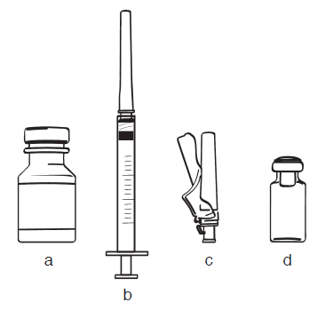
Figure 1

  - Wash your hands with soap and water. Dry your hands with a clean towel.
    - Take the plastic caps off the vials of EGRIFTA and Sterile Water for injections.
    - Clean the rubber stopper on top of the vials with an alcohol swab.

How to mix EGRIFTA
Step 1: Pick up the syringe with needle attached (Figure 1, b), remove the protective cap and insert the needle through the rubber stopper of the bottle of Sterile Water for injections (Figure 1, a; see Figure 2 for illustration). Turn both upside down, and pull back the plunger until the liquid reaches the 2.1 ml mark on the syringe. (See Figure 3)
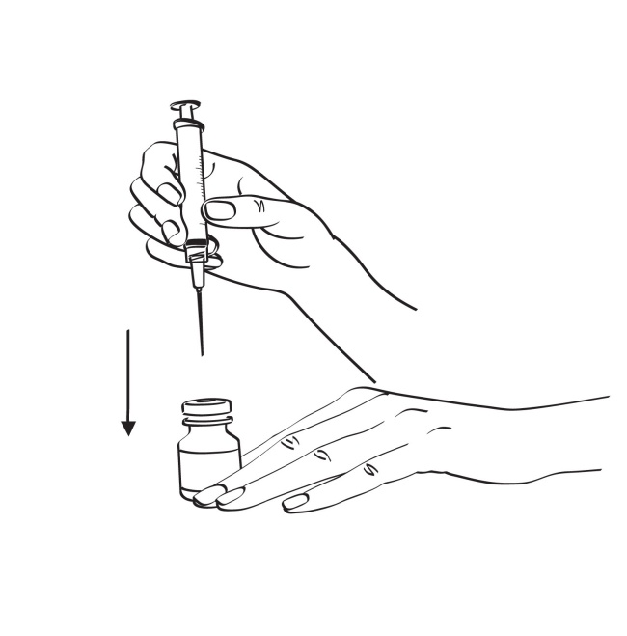
Figure 2
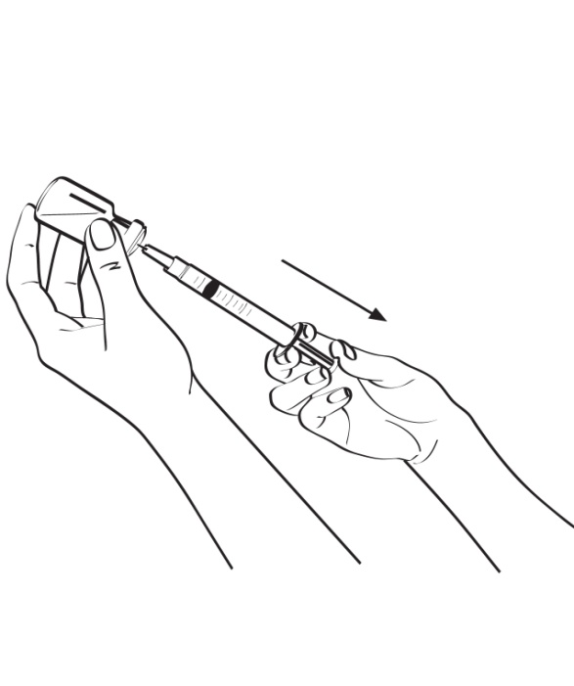
Figure 3

Step 2: Remove the syringe with needle attached from the Sterile Water for injections bottle and insert the needle into the EGRIFTA vial. Push the plunger in slowly on a slight angle so water goes down the inside wall of the EGRIFTA vial instead of directly onto the powder to avoid foaming. (See Figure 4)
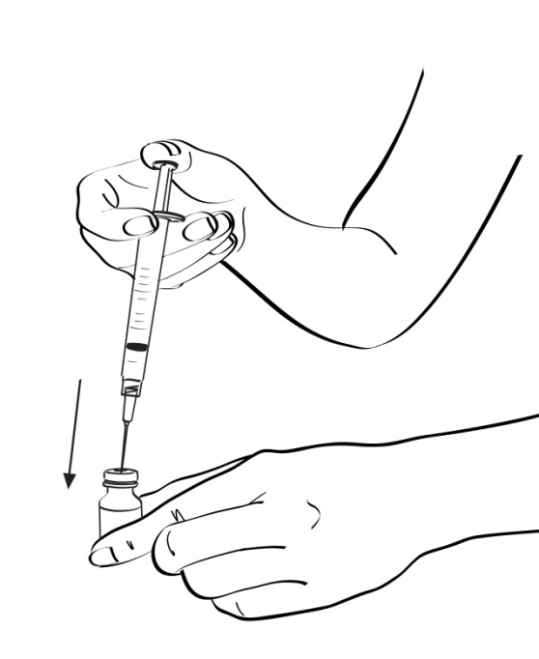
Figure 4
Step 3: While keeping the syringe with needle attached in the vial and the vial upright, roll the vial gently in your hands for 30 seconds, until the Sterile Water for injections and EGRIFTA powder are mixed well. Do not shake the vial. (See Figure 5)
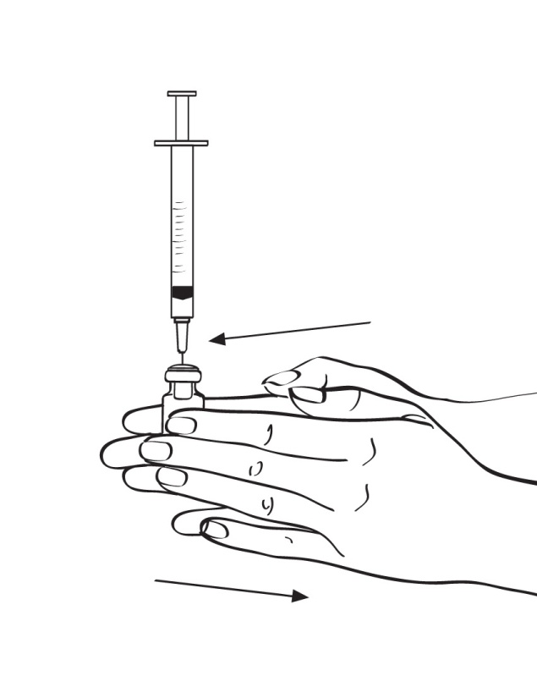
Figure 5
Step 4: Still keeping the syringe with needle attached in the vial, turn both until the syringe is straight up. Pull down on the syringe until you see just the tip of the needle going through the rubber stopper, then pull back on the plunger until all the liquid inside the vial goes into the syringe. The level of medicine in the syringe should be around the 2.1 ml mark on the syringe. (See Figure 6)

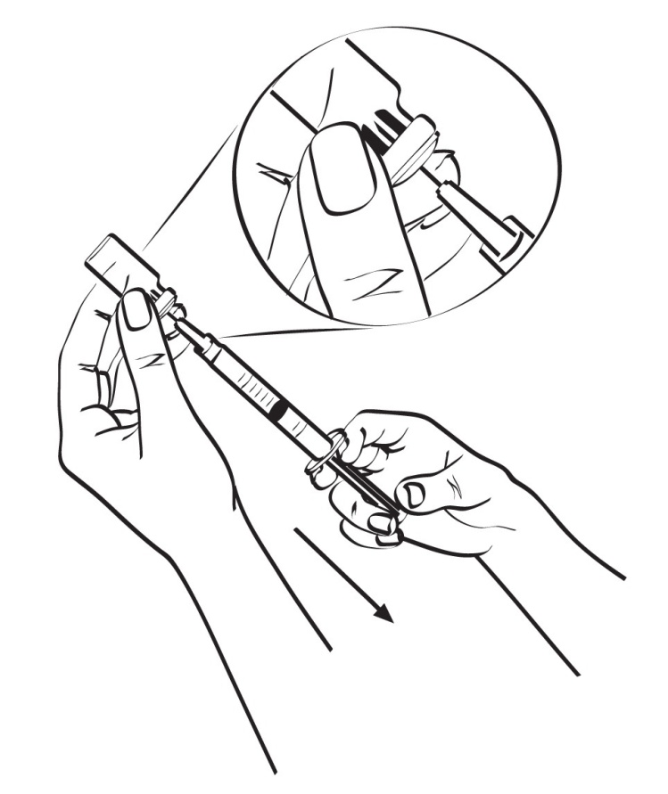

Figure 6

Step 5: Take the needle out of the vial. (See Figure 7)
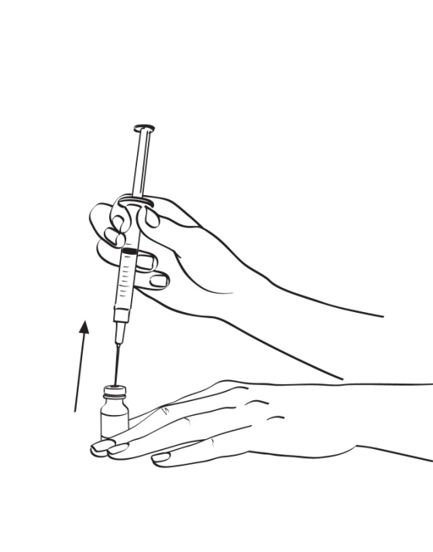
Figure 7
Step 6: Place the needle cap on its side against a clean flat surface. Without touching the needle, hold the syringe and slide the needle carefully into the protective cap. (See Figure 8) Push the cap all the way or until it snaps shut. (See Figure 9) Do not touch the cap until it covers the needle completely.
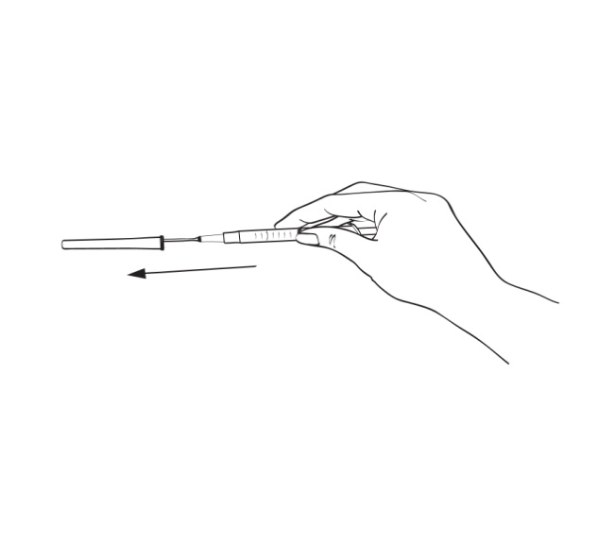

Figure 8
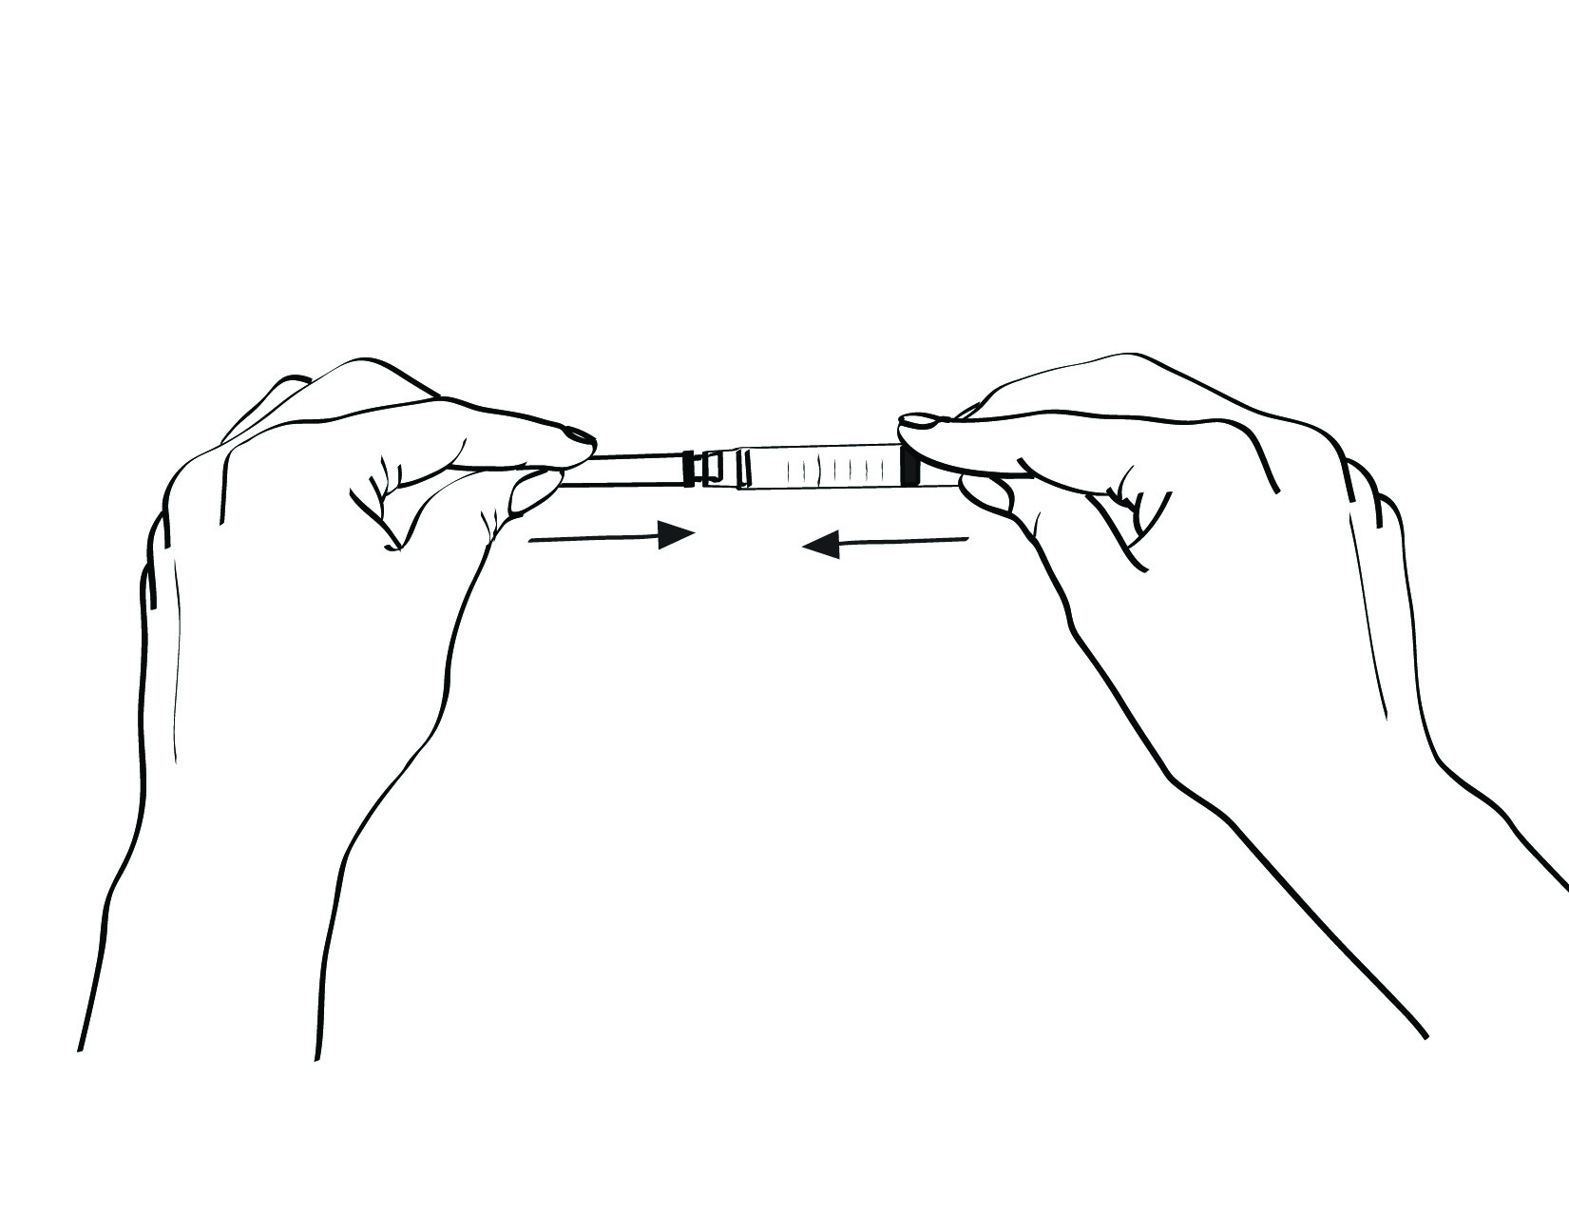

Figure 9

Step 7: With the cap on the needle, remove the needle by holding the syringe firmly and twisting the cap counterclockwise (to the left). (See Figure 10).

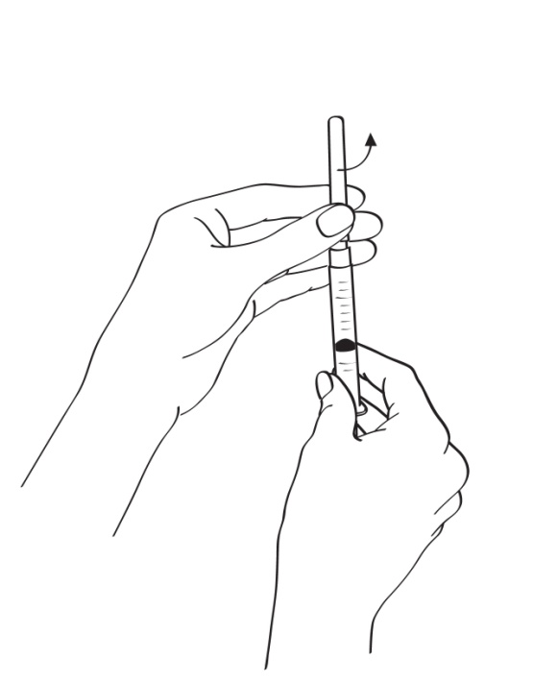
Figure 10

Step 8: Place the injection needle (Figure 1, c), with its protective cap in place, onto the syringe. Hold the syringe firmly and twist the cap clockwise (to the right) until it closes securely. (See Figure 11)
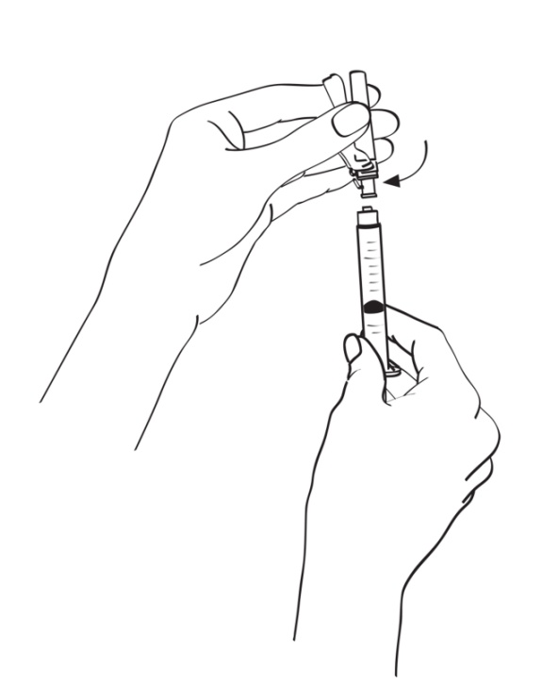
Figure 11

Step 9: After mixing, use EGRIFTA immediately. Do not store mixed EGRIFTA. (see Section 5)

Where do I inject EGRIFTA?
Inject EGRIFTA into the skin on your stomach (abdomen). (See Figure 12)
- Pick an injection site that is below your belly button to the left or right.
- Stay away from any area with scar tissue, bruises, reddening, infection, or irritation.
- Avoid areas with any hard bumps from previous injections.
- Change (rotate) your injection site on your stomach area (abdomen) with each dose, from one day to the next. This may help prevent bruising or irritation. Do NOT inject EGRIFTA into scar tissue, bruises or your navel.
- You may want to keep a note of the date and location of each daily injection to help you remember.
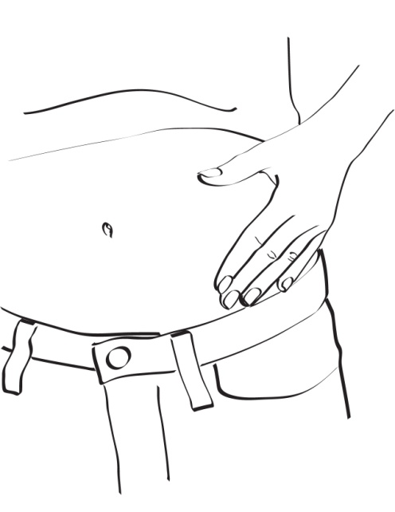
Figure 12

How to inject EGRIFTA
- Pick up the syringe and pull the cap straight off the injection needle. Do not twist it. (See Figure 13)
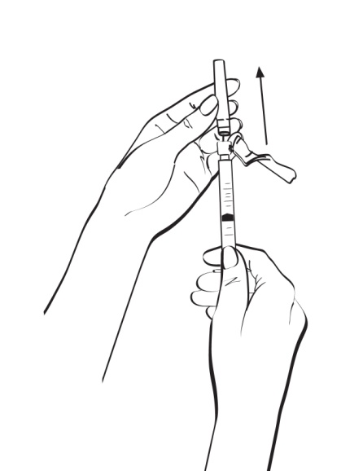
Figure 13

2 Tap the syringe gently with your finger to force any air bubbles to rise to the top. Press the plunger to push bubbles out. (See Figure 14)
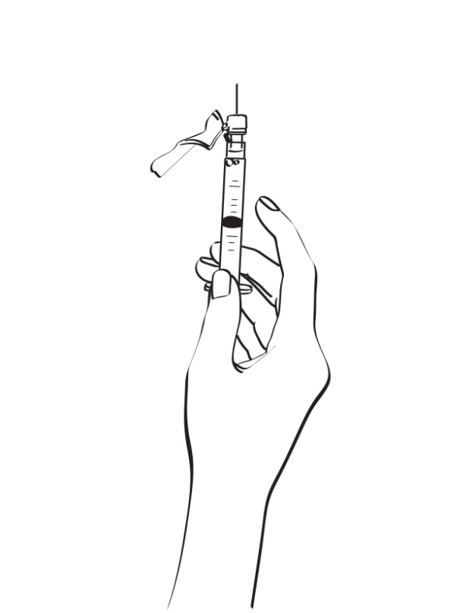
Figure 14

- Clean the injection site you have selected with an alcohol swab and let it dry. Hold the syringe in one hand. Use your other hand to hold a cleaned fold of skin for your injection. Hold the skin between your thumb and fingers. (See Figure 15)
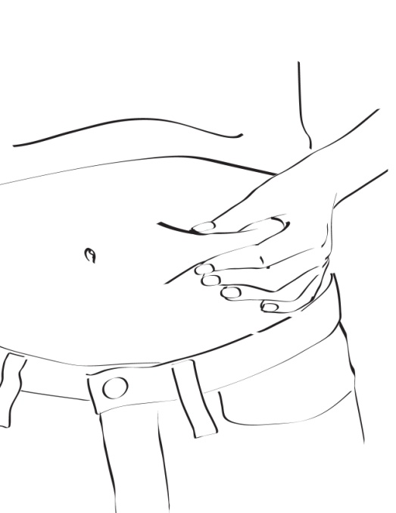
Figure 15

4 Hold the syringe at a right angle to the skin, like a dart. Push the injection needle into the skin with a quick motion. Most of the needle should go beneath the skin surface. (See Figure 16)
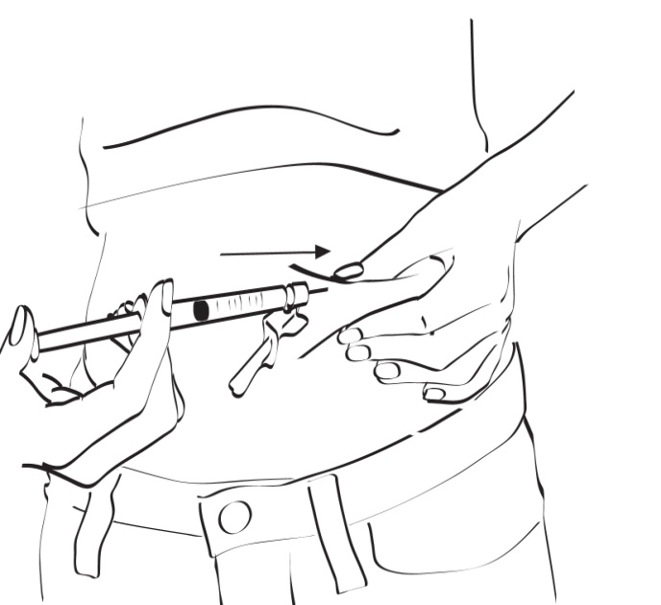
Figure 16

5 Remove your hand from the pinched area of skin after the needle goes in. Make sure the needle stays in the skin. (See Figure 17)
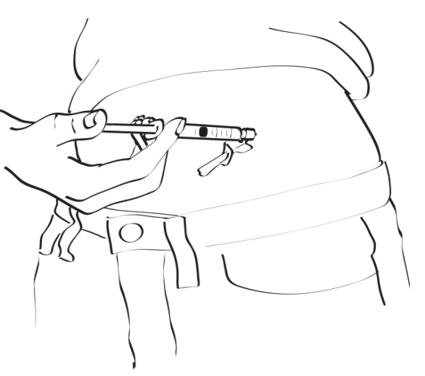
Figure 17
6 Slowly push the plunger all the way down until all of the medicine in the syringe has been injected under the skin.
7 Pull the injection needle out of your skin when the syringe is empty.
8 Be careful to pull it out at the same angle you put it in.
9 Flip back the needle shield until it snaps, covering the injection needle completely. Keep pressing until you hear a click, that means the injection needle is protected. (See Figure 18)

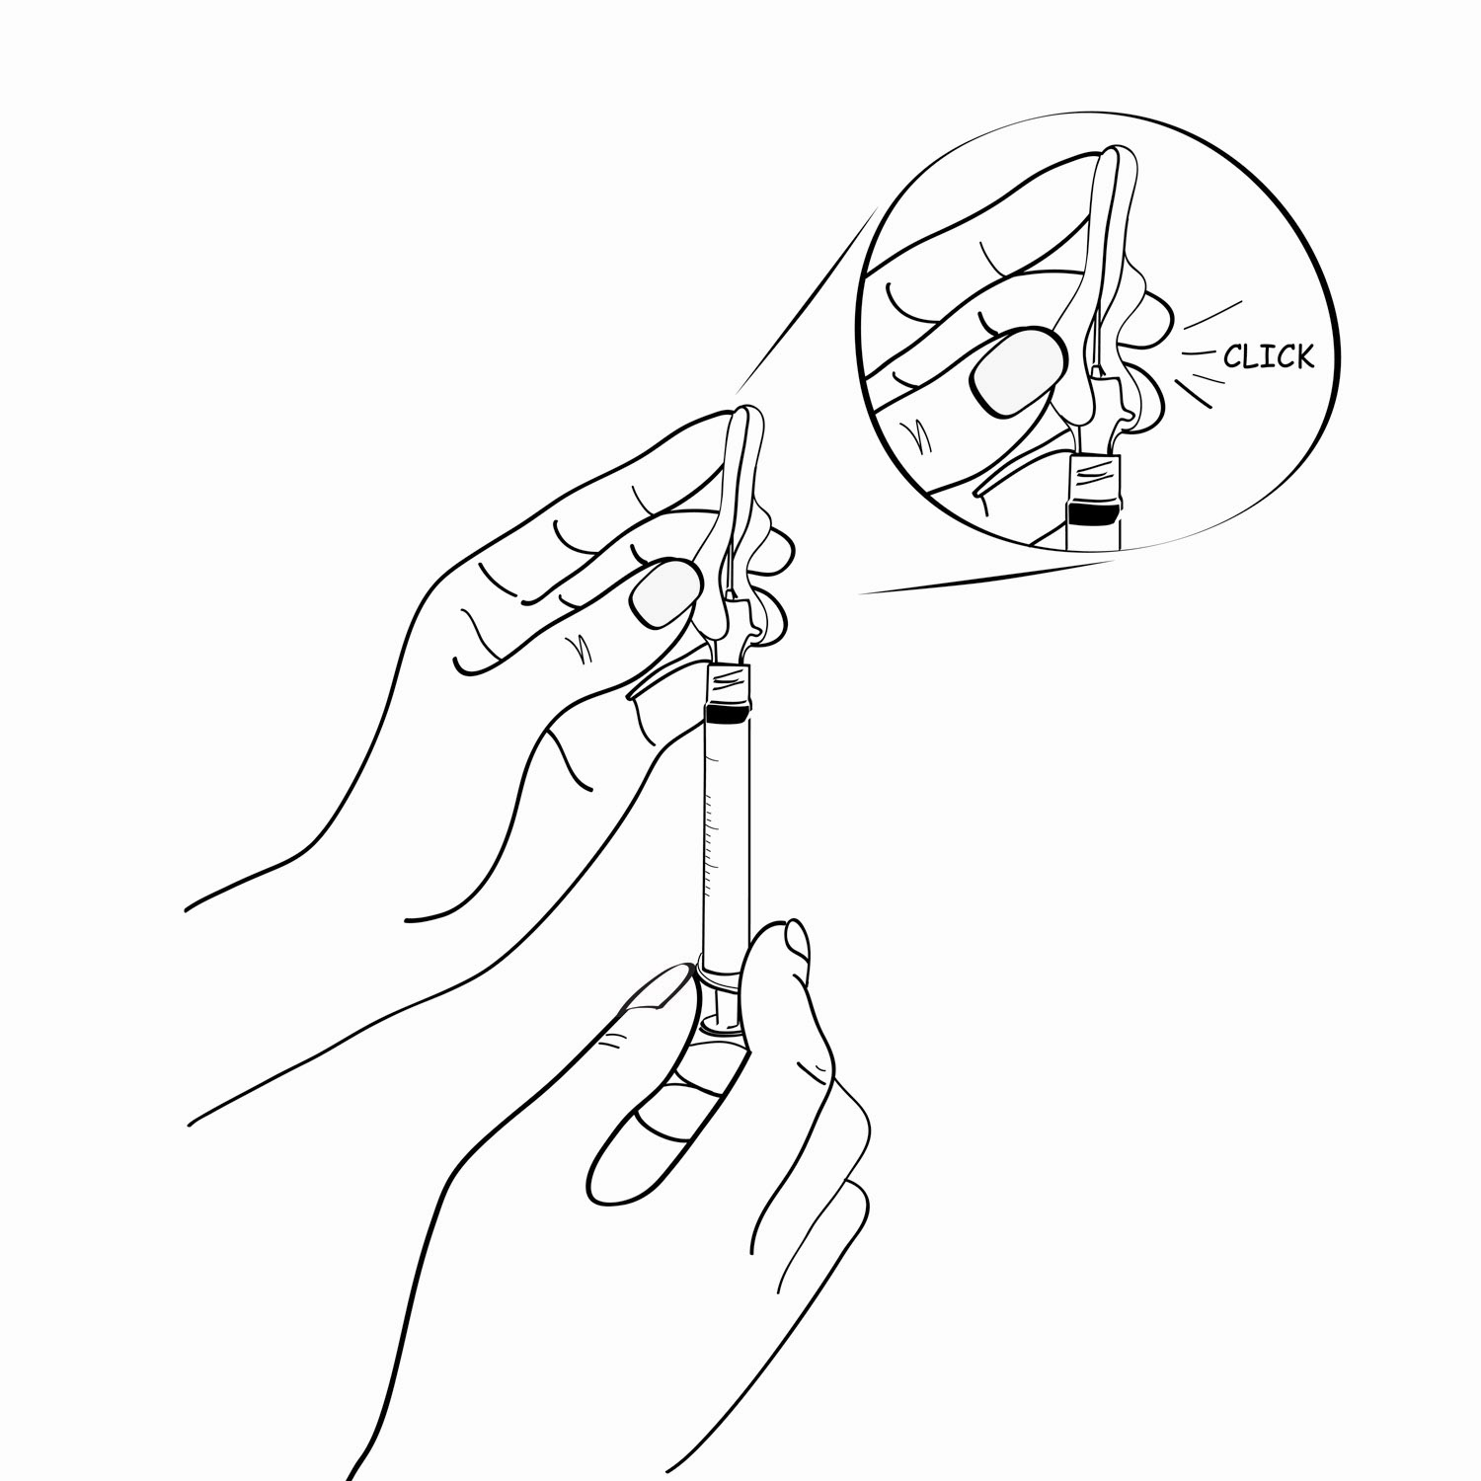
Figure 18

10 Use a piece of sterile gauze to rub the injection site clean. If there is bleeding, apply pressure to the injection site with gauze for 30 seconds. If bleeding continues, apply a bandage to the site.

How should I dispose of the used syringes, needles, bottles and vials? (see also section 5)
- If you accidentally prick another person with a used needle, that person should contact a doctor immediately about the accident.
- Never reuse or recycle needles or syringes.
- Never throw used needles, syringes, or the sharps container into the waste/rubbish bin.
- Safely dispose used syringes, needles, EGRIFTA vials and Sterile Water for injections bottles in a puncture-proof container, sharps container, or a hard container like a coffee can.
- Speak to your pharmacist or other doctor about the proper disposal of the sharps container and all other used materials. There may be local or state laws about how to throw away used needles and syringes.
- Keep the sharps container away from children and pets.

Use in children and adolescents
EGRIFTA is not for use in children and adolescents below 18 years old.

If you use more EGRIFTA than you should

You should tell your doctor or pharmacist.

If you forget to use EGRIFTA
Do not take a double dose to make up for a forgotten injection. Wait until the next dose is due and take one dose as normal.

If you stop using EGRIFTA
This medicine can safely be stopped at any time; however it would be advisable to talk to your doctor before you stop taking this medicine. Return any unused medicine, syringes and needles to your pharmacist.

If you have any further questions on the use of this medicine, ask your doctor or pharmacist.

Marketing Authorisation Holder and Manufacturer

Marketing Authorisation Holder:
Ferrer Internacional, S.A.
Gran Via Carlos III, 94
08028-Barcelona, Spain
Tel: +34 93 600 37 00
Fax: + 34 93 330 48 96ç

Manufacturer
FERRER INTERNACIONAL, S.A.
Joan Buscallà, 1-9
08173–San Cugat del Vallès
Barcelona (Spain)

EGRIFTA is a trademark of Theratechnologies Inc.

For any information about this medicine, please contact the local representative of the Marketing Authorisation Holder:

België/Belgique/Belgien/Belgium  Ferrer-Therabel  Rue Egide Van Ophem 108  B-1180 Brussels, Belgium  Tél/Tel: + 32 2 3704611  generalities@pharma.therabel.com |  | Luxembourg/Luxemburg  Ferrer-Therabel  Rue Egide Van Ophem 108  B-1180 Brussels, Belgium  Tél/Tel: + 32 2 3704611  generalities@pharma.therabel.com
България/Bulgaria  AOP Orphan  Wilhelminenstraße 91/IIf  1160 Wien, Austria  Teл.: + 43 1 503724422  office@aoporphan.com |  | Magyarország/Hungary  AOP Orphan  Wilhelminenstraße 91/IIf  1160 Wien, Austria  Tel.: +43 1 503724422  office@aoporphan.com
Česká republika/Czech Republic  AOP Orphan  Wilhelminenstraße 91/IIf  1160 Wien, Austria  Tel: +43 1 503724422  office@aoporphan.com |  | Malta  V.J. Salomone Pharma Limited  Upper Cross Road  Marsa MRS 1542, Malta  Tel: + 356 212 20174  pharma@vjsalomone.com
Danmark/Denmark  Nordic Infucare  Box 1225  131 28 Nacka Strand, Sweden  Tlf: + 46 86012440  info@infucare.se |  | Nederland/Netherlands  Ferrer-Therabel  Rue Egide Van Ophem 108  B-1180 Brussels, Belgium  Tel: + 32 2 3704611  generalities@pharma.therabel.com
Deutschland/Germany  Trommsdorff  Trommsdorffstr. 2-6  D-52477 Alsdorf, Germany  Tel: + 49 2404 553 01  trommsdorff@trommsdorff.de |  | Norge/Norway  Nordic Infucare  Box 1225  131 28 Nacka Strand, Sweden  Tlf: + 46 86012440  info@infucare.se
Eesti/Estonia  AOP Orphan  Wilhelminenstraße 91/IIf  1160 Wien, Austria  Tel: + 43 1 503724422  office@aoporphan.com |  | Österreich/Austria  AOP Orphan  Wilhelminenstraße 91/IIf  1160 Wien, Austria  Tel: + 43 1 503724422  office@aoporphan.com
 | Ελλάδα/Greece  Ferrer-Galenica  4 Eleftherias str., Kifissia  14564 Athens, Greece  Τηλ: + 30 2105281700  contact@galenica.gr |  | Polska/Poland  AOP Orphan  Wilhelminenstraße 91/IIf  1160 Wien, Austria  Tel.: + 43 1 503724422  office@aoporphan.com
España/Spain  Ferrer Internacional, S.A.  Gran Via Carlos III, 94  08028-Barcelona, Spain  Tel: + 34 93 600 37 00  medicaldepartment@ferrergrupo.com |  |  | Portugal  Ferrer-CPH  Rua dos Bem Lembrados, 141  Manique, 2645-471 Alcabideche, Portugal  Tel: + 351 21 4449600  geral@cphpharma.pt
France  BIOPROJET  9, Rue Rameau  75002 Paris, France  Tél: + 33 1 47036633  contact@bioprojet.com |  |  | România/Romania  Ferrer-Galenica  4 Eleftherias str., Kifissia  14564 Athens, Greece  Tel: + 30 2105281700  contact@galenica.gr
Ireland  Flynn Pharma  Hertlands House, Primett Road  Old Stevenage, Herts SG1 3EE, UK  Tel: + 44 1438 727822  info@flynnpharma.com |  |  | Slovenija/Slovenia  AOP Orphan  Wilhelminenstraße 91/IIf1160 Wien, Austria  Tel: + 43 1 503724422  office@aoporphan.com
Ísland/Iceland  Nordic Infucare  Box 1225  131 28 Nacka Strand, Sweden  46 86012440  info@infucare.se |  |  | Slovenská republika/Slovakia  AOP Orphan  Wilhelminenstraße 91/IIf  1160 Wien, Austria  Tel: + 43 1 503724422  office@aoporphan.com
Italia/Italia  Dompé  Via San Martino, 12-12/a  20122-Milano, Italy  Tel: + 39 02 583831  info@dompe.it |  |  | Suomi/Finland  Nordic Infucare  Box 1225  131 28 Nacka Strand, Sweden  Puh/Tel: + 46 86012440  Info”infucare.se
Κύπρος/Cyprus  Ferrer-Galenica  Eleftherias str., Kifissia  14564 Athens, Greece  Τηλ: + 30 2105281700  contact@galenica.gr |  |  | Sverige/Sweden  Nordic Infucare  Box 1225  131 28 Nacka Strand, Sweden  Tel: + 46 86012440  info@infucare.se
Latvija/Latvia  AOP Orphan  Wilhelminenstraße 91/IIf  1160 Wien, Austria  Tel: + 43 1 503724422  office@aoporphan.com |  |  | United Kingdom  Flynn Pharma  Hertlands House, Primett Road  Old Stevenage, Herts SG1 3EE, UK  Tel: + 44 1438 727822  info@flynnpharma.com
Lietuva/Lithuania
AOP Orphan
Wilhelminenstraße 91/IIf
1160 Wien, Austria
Tel: +43 1 503724422
office@aoporphan.com

This leaflet was last approved in {MM/YYYY}

Detailed information on this medicine is available on the European Medicines Agency web site: http://www.ema.europa.eu.

